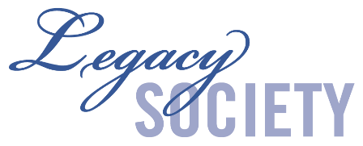
Greater Twin Cities

United Way

404 South Eighth Street
Minneapolis, MN 55404-1084

Name(s): ____________________________________________________

Address: ____________________________________________________

City, State, Zip:___________________________________________

Legacy Society Membership Form

Thank you for your generous support of Greater Twin Cities United Way. You are part of a forward-thinking group of community leaders who have planned a legacy gift to continue our good work for the benefit of future generations. We are privileged to advance a piece of your legacy in this community. Be assured we will treat the following information with the utmost confidentiality and respect.

1. Please describe your gift with as much detail as you are comfortable sharing. We recognize that many estate gifts are revocable, are subject to unknown future personal and financial considerations, and can be modified any time. Currently, my future gift for United Way is through:
A Will A Trust Retirement Plan Assets Life Insurance
Other

2. If possible, please share an estimated value of your planned gift as if it were received at today’s value. Knowing the estimated value of your gift will help us better plan for the future.

The estimated current value of my gift is $_______________________

3. My future gift is: Irrevocable Revocable

4. All friends who plan an estate gift – or make a current gift to our endowment – are gratefully recognized in the United Way Legacy Society. Friends whose future gift is intended to be $250,000 or more are also recognized in the Tocqueville Legacy Circle. We hope you will allow us to recognize your generosity and to list your name(s) as an inspiration to others. Please indicate how your name(s) should appear on any recognition material and annual donor roster:

Name(s)__________________________________________
Please do not list my/our name(s) in any donor rosters or publications.

Signature(s): _______ _____

Date of Birth: _____________________________ ________________________________

Today’s Date:

Please return a copy to our office at Greater Twin Cities United Way 404 S. 8th St., Minneapolis, MN 55404. THANK YOU for your part in supporting United Way’s work in our community!

Linne Lemke, CFRE
This form expresses my intentions but in no way makes me or my estate legally or morally obligated to fulfill them if I choose to modify or cancel this planned gift at a later date.
Planned Giving Officer
612-340-7434 | Linne.Lemke@gtcuw.org

